P 8 Inter-VLAN Routing with an External Router
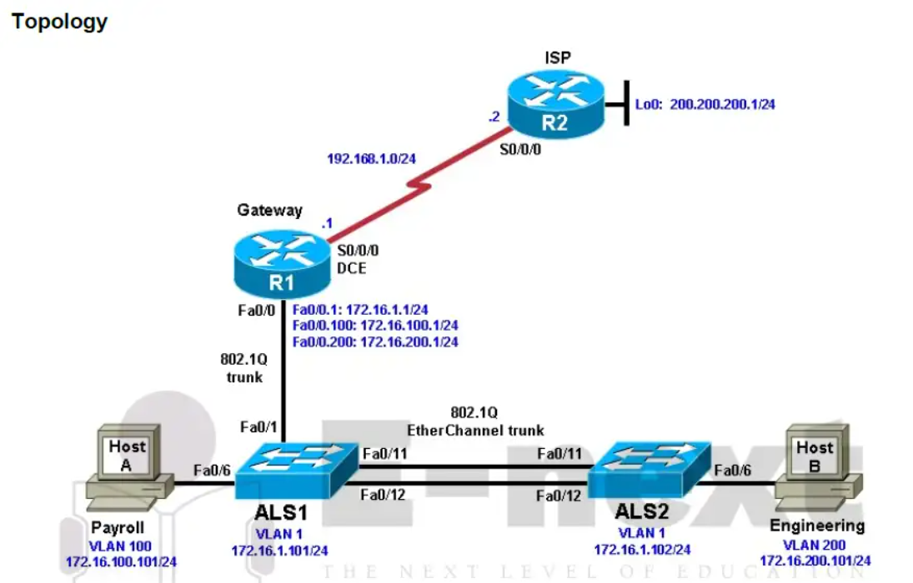

Background
Inter-VLAN routing using an external router can be a cost-effective solution when it is necessary to segment a
network into multiple broadcast domains. In this lab, you split an existing network into two separate VLANs on
the access layer switches, and use an external router to route between the VLANs.

Required Resources
• 2 routers (Cisco 1841 with Cisco IOS Release 12.4(24)T1 Advanced IP Services or comparable)
• 2 switches (Cisco 2960 with the Cisco IOS Release 12.2(46)SE C2960-LANBASEK9-M image or comparable)

Step 3: Configure the routers.

Router(config)# hostname ISP
ISP(config)# interface Loopback0
ISP(config-if)# ip address 200.200.200.1 255.255.255.0
ISP(config-if)# interface Serial0/0/0
ISP(config-if)# ip address 192.168.1.2 255.255.255.0
ISP(configif)# no shutdown
ISP(config-if)# exit
ISP(config)# ip route 172.16.0.0 255.255.0.0 192.168.1.1

Router(config)# hostname Gateway
Gateway(config)# interface Serial0/0/0
Gateway(config-if)# ip address 192.168.1.1 255.255.255.0
Gateway(config-if)# clockrate 64000
Gateway(config-if)# no shutdown
Gateway(config-if)# exit
Gateway(config)# ip route 0.0.0.0 0.0.0.0 192.168.1.2

Step 4: Configure the switches.

Switch(config)# hostname ALS1
ALS1(config)# interface vlan 1
ALS1(config-if)# ip address 172.16.1.101 255.255.255.0
ALS1(config-if)# no shutdown
ALS1(config-if)# exit
ALS1(config)# ip default-gateway 172.16.1.1

Switch(config)# hostname ALS2
ALS2(config)# interface vlan 1
ALS2(config-if)# ip address 172.16.1.102 255.255.255.0
ALS2(config-if)# no shutdown
ALS2(config-if)# exit
ALS2(config)# ip default-gateway 172.16.1.1

ALS1(config)# enable secret cisco
ALS1(config)# line vty 0 15
ALS1(config-line)# password cisco
ALS1(config-line)# login
ALS1(config-line)# end
ALS2(config)# enable secret cisco
ALS2(config)# line vty 0 15
ALS2(config-line)# password cisco
ALS2(config-line)# login
ALS2(config-line)# end

Step 5: Confirm the VLANs.

ALS1# show vlan

Step 6: Configure trunk links and EtherChannel on switches.

ALS1# configure terminal
Enter configuration commands, one per line. End with CNTL/Z.
ALS1(config)# interface range fastEthernet 0/11 - 12
ALS1(config-if-range)# switchport mode trunk
ALS1(config-if-range)# channel-group 1 mode desirable
ALS1(config-if-range)# end

ALS2# configure terminal
Enter configuration commands, one per line. End with CNTL/Z.
ALS2(config)# interface range fastEthernet 0/11 - 12
ALS2(config-if-range)# switchport mode trunk
ALS2(config-if-range)# channel-group 1 mode desirable
ALS2(config-if-range)# end

ALS1# show etherchannel 1 summary

Step 7: Configure VTP.

ALS2(config)# vtp mode client
Setting device to VTP CLIENT mode.

ALS1(config)# vtp domain SWLAB
Changing VTP domain name from NULL to SWLAB
%SW_VLAN-6-VTP_DOMAIN_NAME_CHG: VTP domain name changed to SWLAB.

ALS1(config)# vtp version 2
ALS1# show vtp status

ALS2# show vtp status

ALS1(config)# vlan 100
ALS1(config-vlan)# name Payroll
ALS1(config-vlan)# vlan 200
ALS1(config-vlan)# name Engineering

ALS2# show vlan brief

ALS1(config)# interface fastEthernet 0/6
ALS1(config-if)# switchport mode access
ALS1(config-if)# switchport access vlan 100
ALS1(config-if)# spanning-tree portfast

ALS2(config)# interface fastEthernet 0/6
ALS2(config-if)# switchport mode access
ALS2(config-if)# switchport access vlan 200
ALS2(config-if)# spanning-tree portfast

ALS1# show vlan brief

ALS2# show vlan brief

ALS1(config)# interface fastEthernet 0/1
ALS1(config-if)# switchport mode trunk
ALS1(config-if)# end

Step 10: Configure the Gateway router Fast Ethernet interface for VLAN trunking.

Gateway(config)# interface fastEthernet 0/0
Gateway(config-if)# no shut
The following is a sample configuration for the VLAN 1 subinterface.
Gateway(config)# interface fastEthernet 0/0.1
Gateway(config-subif)# description Management VLAN 1
Gateway(config-subif)# encapsulation dot1q 1 native
Gateway(config-subif)# ip address 172.16.1.1 255.255.255.0

Gateway(config-subif)# interface fastEthernet 0/0.100
Gateway(config-subif)# description Payroll VLAN 100
Gateway(config-subif)# encapsulation dot1q 100
Gateway(config-subif)# ip address 172.16.100.1 255.255.255.0

Gateway(config-subif)# interface fastEthernet 0/0.200
Gateway(config-subif)# description Engineering VLAN 200
Gateway(config-subif)# encapsulation dot1q 200
Gateway(config-subif)# ip address 172.16.200.1 255.255.255.0
Gateway(configsubif)# end
Gateway# show ip interface brief
Gateway# show interfaces description
Gateway# show vlans

